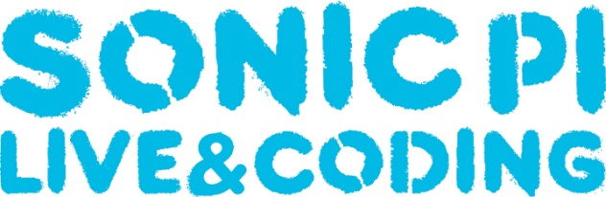
Scheme of Work

Sonic Pi is an application/program designed by live coder/developer Sam Aaron, originally for a Raspberry Pi computer. It is open source software developed in Super Collider with the objective of using code language to write music. Sonic Pi is a creative way for students to engage in electronic music composition through a fun and new method. Using Sonic Pi also introduces students to music technology, an upcoming and economically growing field, at an earlier level than degree or A-level.

Lesson 1: Students will be exploring the Raspberry Pi/Sonic Pi independently and begin using basic terms to complete a familiar tune. | Terms: play, sleep, run
Lesson 2: After exploring Sonic Pi in the previous week, students will begin to use the terms: loop do, and use_synth. Students will continue with last week’s piece or create their own. | Terms: loop do, end, use_synth
Lesson 3: Students will engage with new terms such as: use_sample to create a drum loop within Sonic Pi, as well as develop an understanding of the origins of electronic samples. | Terms: sample:, sleep sample_duration
Lesson 4: Students will experiment with texture using the thread function within Sonic Pi. This will allow students to use multiple loops and instruments | Terms: in_thread do, end
Lesson 5: Students will engage with the idea of serial music and attempt to create their own using the rrand and .choose function | Terms: rrand, .choose
Lesson 6: Students will develop their current knowledge and begin work on their final composition using the briefs and assessment criteria provided as guidance. | Terms:
Lesson 7: Students will begin to use and explore FX functions within Sonic Pi and add them to their final compositions. | Terms: with_fx:, reverb, echo, rlpf
Lesson 8: Students will begin to manipulate sound through parameter functions such as attack, and release. | Terms: attack, release, sustain
Lesson 9: Students will discuss how to musically recreate sounds and begin work on their soundscape compositions using all the knowledge developed to date. | Terms:
Lesson 10: Students will finish their soundscapes and prepare for next week’s final performance. Deadline for final composition. Deadline for final composition and review | Terms:
Lesson 11: Student will use all of their knowledge developed throughout the term to participate in a class performance of a Sonic Pi Orchestra. | Terms:

