Game 24 using Python

24 pulls on a range of mathematical thinking and skills, including addition, subtraction, multiplication, division, order of operations, and number sense. Using Python to play 24 is a creative and fun way to practice math skills whole class or individually while also introducing students to the python language and how to run programs using IDLE.

For this program I used IDLE, a python environment that can be found on the Python website under downloads, https://www.python.org/downloads/.

- Open a new file
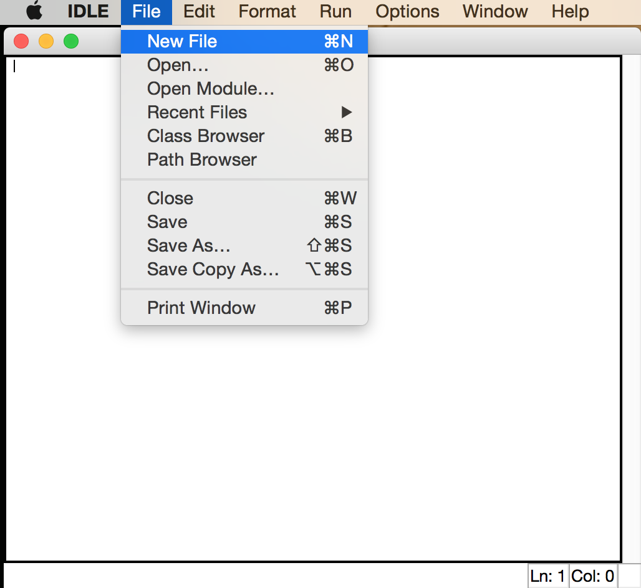
- Copy and paste this code into the new file

'''
The 24 Game

Given any four digits in the range 1 to 9, which may have repetitions,
Using just the +, -, *, and / operators; and the possible use of
brackets, (), show how to make an answer of 24.

An answer of "!" will generate a new set of four digits (if your stuck).
Otherwise you are repeatedly asked for an expression until it evaluates to 24

Note: you cannot form multiple digit numbers from the supplied digits,
so an answer of 12+12 when given 1, 2, 2, and 1 would not be allowed.

'''
from __future__ import division, print_function
import random, ast, re
import sys

if sys.version_info[0] < 3: input = raw_input

def choose4():
'four random digits >0 as characters'
return [str(random.randint(1,9)) for i in range(4)]

def welcome(digits):
print (__doc__)
print ("Your four digits: " + ' '.join(digits))

def check(answer, digits):
allowed = set('() +-*/\t'+''.join(digits))
ok = all(ch in allowed for ch in answer) and \
all(digits.count(dig) == answer.count(dig) for dig in set(digits)) \
and not re.search('\d\d', answer)
if ok:
try:
ast.parse(answer)
except:
ok = False
return ok

def main():
digits = choose4()
welcome(digits)
trial = 0
answer = ''
chk = ans = False
while not (chk and ans == 24):
trial +=1
answer = input("Expression %i: " % trial)
chk = check(answer, digits)
if answer.lower() == 'q':
break
if answer == '!':
digits = choose4()
print ("New digits:", ' '.join(digits))
continue
if not chk:
print ("The input '%s' was wonky!" % answer)
else:
ans = eval(answer)
print (" = ", ans)
if ans == 24:
print ("Thats right!")
main()

It should look like this:
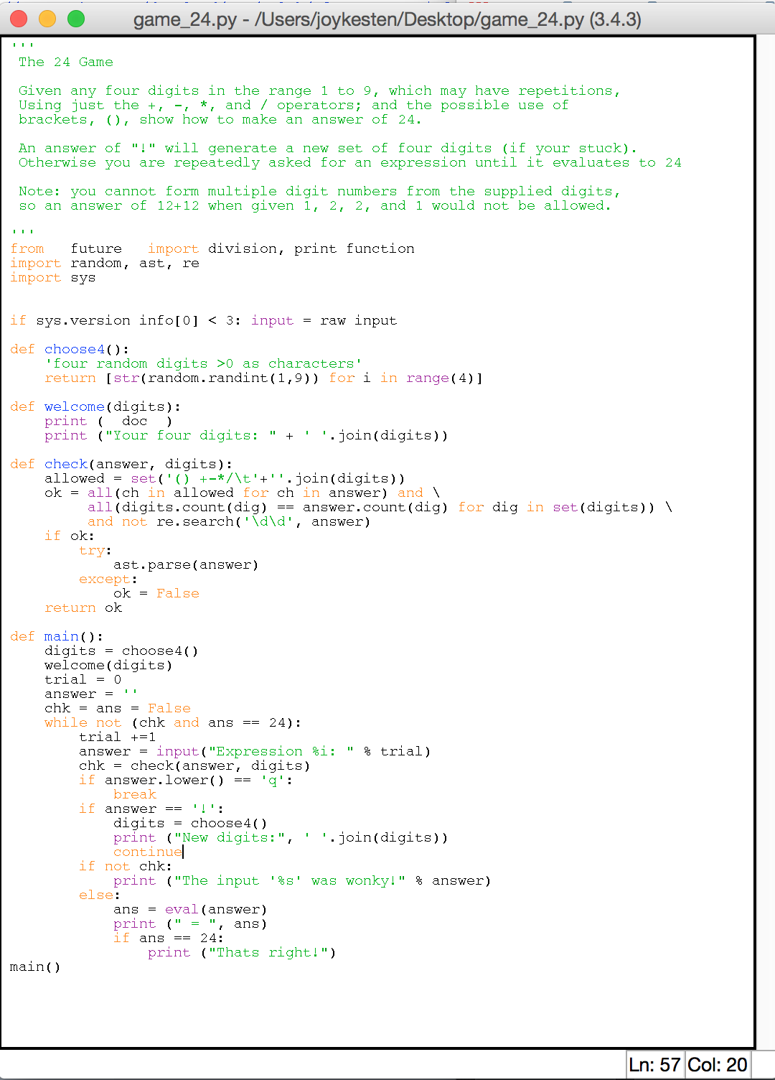

- Save the program as “game_24.py”; you can either do this by going to the file menu or shortcut keys, ie. Command + s on a Mac; Conrol + s on a PC
- Run the Module. When you click “Run Module” or F5, the Python Shell will appear and look like the image in Step 5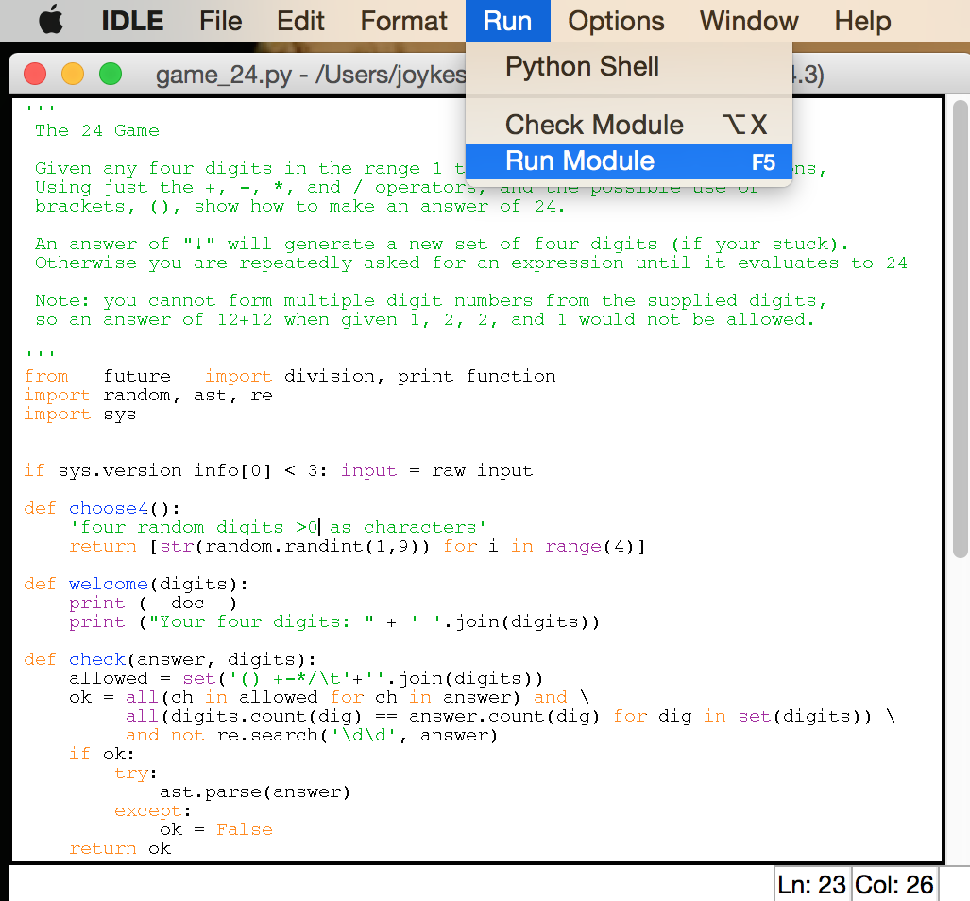

- Lastly! Play the game